**ONLINE EVENT MANAGEMENT SYSTEM**

**ABSTRACT**

In the dynamic landscape of sports and events, efficient planning, scheduling, and management are paramount. To address these challenges, we introduce ABC, a comprehensive web application tailored for organizing and overseeing competitions.

**Key Features**:

**Unified Platform**: ABC provides a centralized hub for competition organizers, athletes, and stakeholders. It streamlines communication and collaboration.

**Event Scheduling**: The application facilitates seamless scheduling of events, ensuring optimal utilization of resources and minimizing conflicts.

**Participant Registration**: ABC allows athletes to register online, simplifying the registration process and reducing paperwork.

**Real-Time Updates**: Users receive real-time notifications about schedule changes, results, and important announcements.

**Resource Allocation**: The system intelligently allocates venues, equipment, and personnel based on event requirements.

**Analytics Dashboard**: ABC offers insights into participation trends, revenue generation, and performance metrics.

By adopting ABC, organizations can enhance efficiency, reduce manual effort, and elevate the overall experience of participants and spectators.

**HARDWARE AND SOFTWARE REQUIREMENTS**

**Hardware Requirements:**

* **Server**: Physical or VPS hosting for deployment.
* **Storage**: Adequate space for project files, database, and media files.
* **Memory(RAM)**: Minimum 1GB for small-scale applications.
* **Network**: Stable internet connection with sufficient bandwidth.

**Software Requirements:**

* **Python**: Version 3.11 installed.
* **DjangoFramework**: Installed using pip.
* **DatabaseManagementSystem (DBMS)**: PostgreSQL, MySQL, or SQLite.
* **IntegratedDevelopmentEnvironment(IDE**): PyCharm, VS Code, or Sublime Text.
* **Git**: Version control system for managing code.

**CLASS DIAGRAM**

|  |
| --- |
| **Event category**  N  N |
| * eventId: int * eventName: string * eventDescription: string * eventType : string |
| * addSlot(slot: Slot): void * removeSlot(slot:Slot): void * updateSlot(slot:Slot): void   N  N  1 |

|  |
| --- |
| **Participant** |
| * participantId: int * participantName: string * participantEmail: string |
| * viewAvailableSlot(slot: Slot): void * chooseSlot(slot: Slot):void * cancelSlot(slot: Slot): void |

|  |
| --- |
| **Slot**  1 |
| * slotId: int   N   * startTime: datetime * endTime: datetime |
| * SlotBooking():void * ticketGeneration():void   1 |

|  |
| --- |
| **Admin** |
| * adminId: int * adminName: string * adminEmail: string |
| * ViewAllEvents(): void * GivePermissions():void * Verification():void |

|  |
| --- |
| **Competition** |
| * competitionId: int * event: Event * participants: List<Participant>   1   * slots: List<Slot> * admin: Admin   1 |
| * getEvent(): Event * addParticipant(participant: Participant): void * removeParticipant(participant: Participant): void * getSlots(): List<Slot> * adminVerification():void |

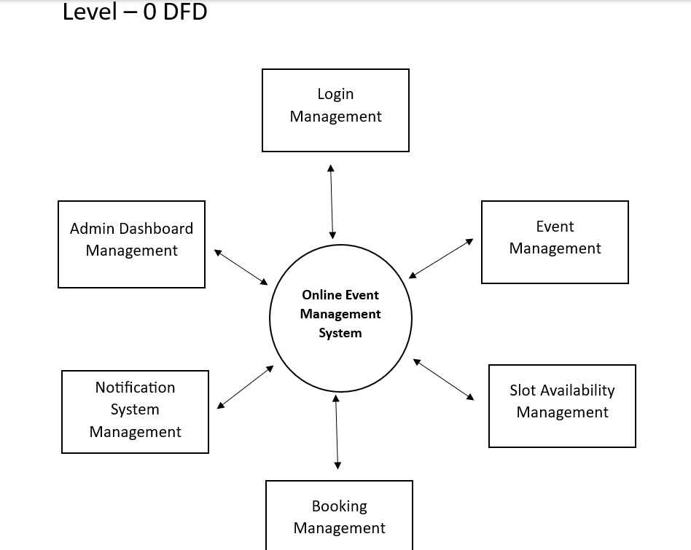

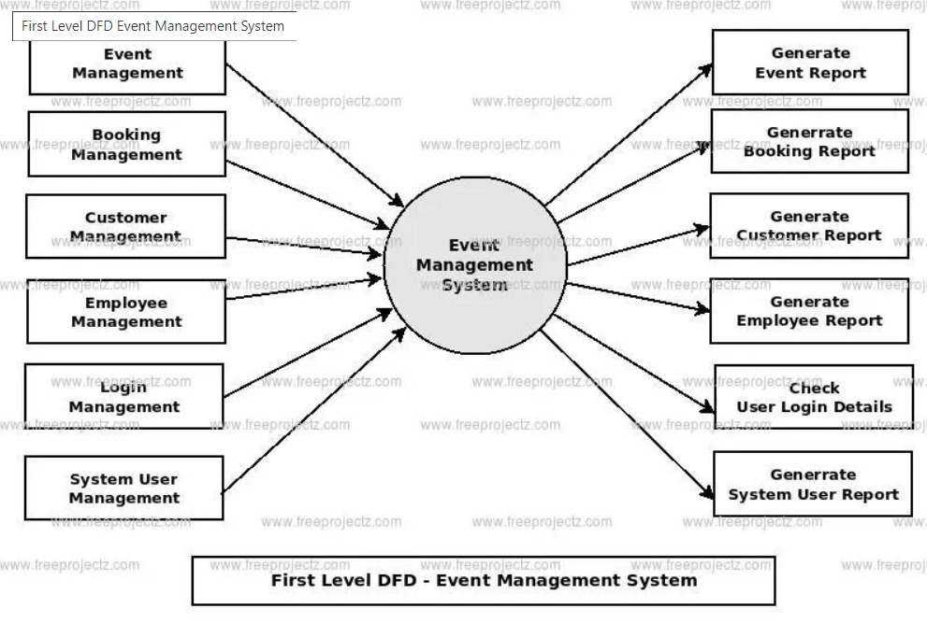

**Profile**

**Participant**

**Slot**

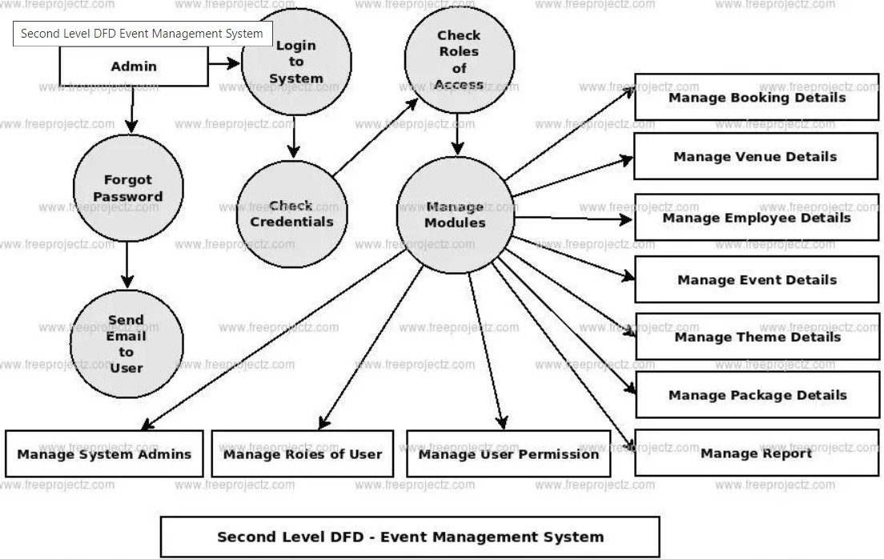

**Ticket**

**Manage participant details**

**Slot**

By Sayantani, Saikat, Sanjeevi, Praveen